INTERNSHIPS:
What they are and
how to get one!
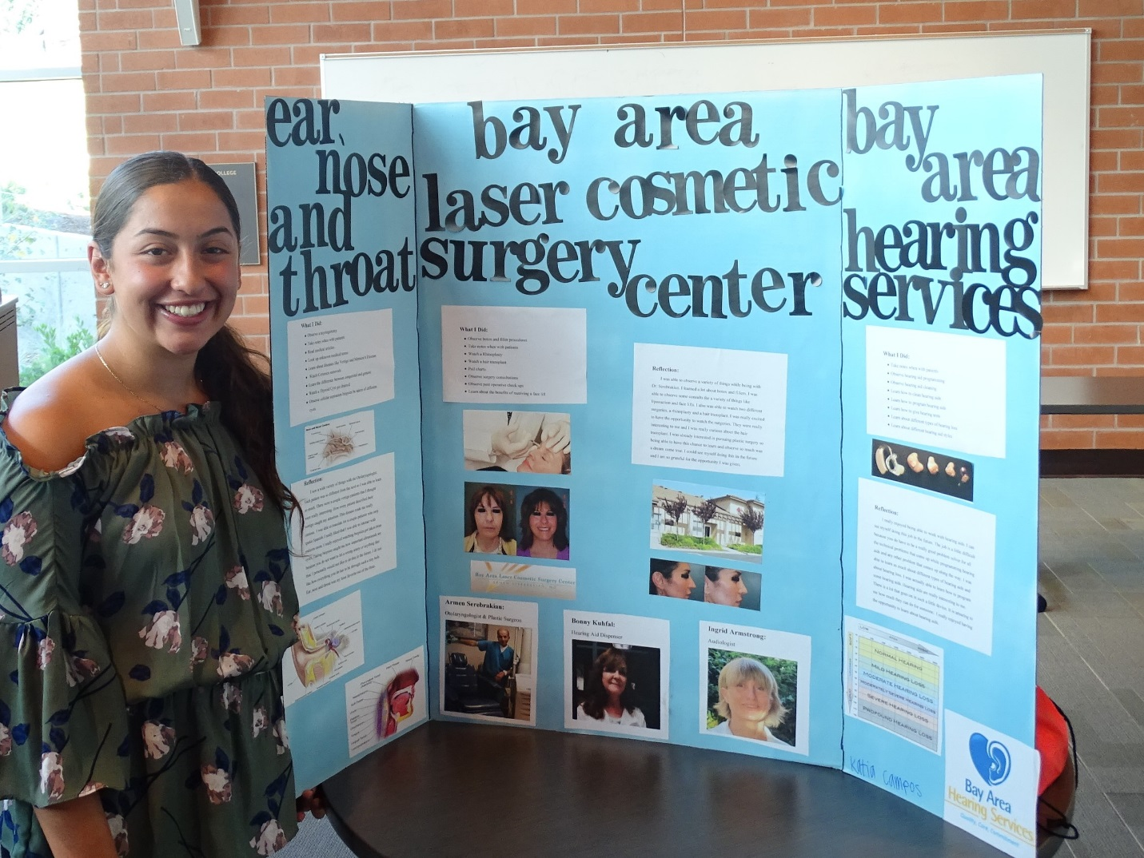
What are Internships?
An internship is an opportunity for students who are interested in a certain profession, but do not have the appropriate training yet, to work and get experience in the professional field. Internships are offered by companies or organizations who want to provide training and entry level work to students, exposing them to the profession first-hand. Participating in an internship is an important part of your pathway educational experience! A summer internship can last 4-8 weeks or longer, and could lead to future opportunities with the organization. Many internships are paid but some are not; it’s important to look for one that matches your particular learning and earning needs for the summer. The main purpose of the internship is not earning, but learning: gaining experience to expand on your career interests and become a competitive applicant for future jobs or other opportunities. Internships not only help you obtain real work experience in a professional field that interests you, but also can help you reach your goals or next steps in your plans for college and career.

Why are Internships Useful?
As a high school student, you’ve been told that internships look great on college applications. Honestly, this is great advice even if you aren’t planning to attend college right after graduation, because an internship can help your possibilities of obtaining a job! These days, good grades are important to impress employers. But an internship experience can give you a competitive advantage over your peers, and would make it easier to present yourself as a qualified and prepared applicant.
An internship will also allow you to obtain job hunting and interview skills. It will help you obtain hands-on experience in your preferred profession, learn skills that could be used for most other jobs, and allow you to have real-life experiences working with professional adults. Internships allow you to network with professionals and establish a relationship with a possible mentor. The internship could be listed on your resume and a potential recommendation letter can come from your employer or mentor. If you succeed at your internship, the hosting organization might want to turn your short-term position to a full-time job! Internship experience can help you become the best candidate in the application pool for your next job or college applications!
An internship will give you more than just exposure to your preferred and dreamed profession in the future. If you apply to internships, you will gain exposure to real life experiences, create a network with people who could possibly offer you a full-time job when you’re done with your internship, and obtain a mentor that could help you navigate your future college and career paths. For a student that undergoes an internship, it could be eye-opening in realizing whether or not you want to choose that career path or move on to another profession that excites you. It is part of the [good] growing pains that come with real life experiences.

How to Write a Brag Sheet
A Brag Sheet is a profile in which you brag about yourself and your accomplishments. Think about these things and then expand on your involvements, using these headings:

- COURSEWORK OTHER THAN A–G, you add any courses that you took as electives, such as college classes, art or music class, etc. It enables you to seem like a well-rounded student that goes above and beyond.
- EDUCATIONAL PREPARATION PROGRAMS, you add courses that have served as college preparation and enrichment such as Girls Inc., Upward Bound, etc.
- VOLUNTEER AND COMMUNITY SERVICE, you list any unpaid work you have done whether it is work in the community garden, food bank, homeless shelter, etc.
- WORK EXPERIENCE, you list all of the paid jobs you have had like Home Depot, Foster Freeze, etc.
- AWARDS AND HONORS, you add any awards you have received such as honor roll, math wizard, etc. In EXTRACURRICULAR ACTIVITIES, you add all the activities you have been a part of since 9th grade such as student government, teacher’s assistant, mentor, etc.

What is a Cover Letter?
A cover letter introduces you and your resume to potential employers. It is the first document an employer will see. When the position you are seeking is an internship, you will probably need to modify the cover letter to fit the particular internship offering and the instructions on how to apply for the internship. A cover letter, however, is always a great way to pull together all of the other documents you may be including in a job or internship application. Take advantage of this important first impression and state why you are writing, why you would are especially interested in the internship or why are a good match for the job and the organization, and that you look forward to hearing from them. If the internship you are applying to is our district program, the Career Pathways Internships, you may direct your letter to Ms. Terri Waller and Ms. Mary Kadri. When you are writing to two people, as in this case, use: Dear Ms. Waller and Ms. Kadri. (Address is West Contra Costa USD, College & Career Department, 2465 Dolan Way, San Pablo, CA 94806), Make sure to DOUBLE CHECK for spelling and grammar. Ask someone you trust, like your teacher, to proof-read it for you! Below is a sample cover letter.
See Cover Letter Template:

Your Name
Your present address
City, State, Zip Code

Date of writing
Mr./Ms./Dr. Last Name
Title
Company
Street/Mailing Address
City, State, Zip Code
Dear Mr./Ms. Last Name:
Opening paragraph: Tell why you are writing; name the internship (or type of internship) that you are asking about, and tell the employer how you heard of the internship or job and how interested you are in this opportunity or position.

The “body:” Mention a couple qualities you have for the internship or job, keeping in mind what the employer or internship provider wants. Tell why you are interested in the company or organization. Be genuine and specific, and list things you learned about the company or organization while you were looking them up. If you have specific experience or skills for the internship or job make sure to point them out, but don’t repeat exactly what you have on your resume, instead invite them to take a look at it.
Closing paragraph: Ask for an interview (if appropriate to the situation) and say when you are available. Also mention that you will call them to confirm the appointment. It is important to take action and create these opportunities for yourself to really show the employer that you are serious about this internship or job. This will improve your chances of getting a personal interview.
Sincerely,
(your signature)
Type your name below signature
Enclosure
(attach your resume)
How to Write a Resume
Do not worry, you are not alone, writing a resume is rather intimidating and stressful for everyone. It is difficult to know what to include, highlight, emphasize and what to exclude, when Human Resources and professionals will have hundreds of applications sitting right on their desks.
A resume needs to be concise, easy to read, and reflect you and your interests. Most resumes are made up of five categories to present your profile, including past work experiences, skills, education, honors and activities, and your references. Your profile must reveal who you are, like what are your special skills, how many languages you speak, etc. Make sure you add the skills you’re most proud of. Your experience should include the jobs, internships, and your extra-curricular activities in chronological order, beginning with the most recent. Include a short summary of what you did and when you did it. Your skills are straight to the point: what are you good at? What skills do you have that make you stand out? Include specific skills that you acquired in your pathway; for example the software programs you are proficient in using, projects that you have designed or worked on. Think about times you showed leadership, worked collaboratively, communicated with adults to achieve a purpose, and especially any community service you have engaged in and what that entailed. Your education includes the school you attend and the pathway you are in. Your honors and activities includes honors such as honor roll, high-achieving programs, etc. Your references refer to people who are willing to advocate for you, or able to speak positively about you to another professional who is considering you for an internship or job.
Make sure to DOUBLE CHECK for spelling and grammar. Ask someone you trust to proof-read it for you! Below is a sample resume. You may decide to access a resume template on line. This is a good idea as it often gives your resume a more polished look. In that case, look for a template that emphasizes skills, rather than past employment experience, since you are still in high school. Even if you use a template, make sure everything “lands” in the right place. Proofread!

Sample Resume follows:

First Name Last Name
Phone: 111.111.1111
Email: First.lastname@email.com

PROFILE
Honor roll high school student with a passion for working with children. Extensive experience working with youth of a variety of ages. Praised and awarded for organizational skills and ability to develop safe, fun environment for children.

SKILLS
-Bilingual: Fluent in English and Spanish
-Proficient in Microsoft office and Google tools
EDUCATION
-Pepperona Central High School, Pepperona, CA
Pathway (Academy)
-High School Diploma anticipated in May 20XX
-GPA 3.86, honor roll each semester
-Electives: Screen printing, Culture & Foods, Independent Living, Family Advocacy Activities: Wind Ensemble, Stage Crew
HONORS & ACTIVITIES
-Member of Arlington High School Tennis Team
-Girl Scout
-Piano, 10 years

EXPERIENCE
Sales Associate, The Retail Store
June 20XX – Present
-Maintain and restock inventory.
-Provide customer service.
Child Care
20XX - Present
-Provide childcare for children after school, weekends, and during school vacations.
-Develop and implement fun, educational activities for children ages 1 year to 8 years.
Run for Life, Volunteer
Assist in marketing (via social media), setting up booths, running registration, and cleaning up for bi-annual race.
REFERENCES
Name of person, Position if applicable, Relation to you, Contact info (email or phone)
How to Get a Reference
A reference is someone who advocates on your behalf. Your references could be anyone: a teacher, an aunt or uncle that you have worked with, your principal, or even your soccer coach. It is basically an adult who can speak positively about your abilities and how reliable you are.
Not sure how to get that reference? Just ask! Whether it was cleaning your uncle’s backyard or helping your aunt babysit her dogs, your work does not go unnoticed. It can be used to your advantage when it comes down to applying for the internship you want. All you have to do is ask them to speak on your behalf based on the work or the relationship you both have.
You then would include their full contact information and relation to you with your internship application, so that the person reviewing your resume and cover letter can call your reference to get a better picture of who you are, your abilities, and work ethic. Always ask your reference before you share their information, so they are not caught by surprise if they get a call from a potential employer or internship selection committee. Get their permission to be listed!

Checklist of what you need to apply for an internship
As there are steps and planning needed for any application, it is the same for certain internships. As you prepare to apply for summer internships this year, make sure you can check the following boxes:
- Gather documents such as the application, resume, transcripts, letters of recommendations, and other possible needed documents.
- Look for opportunities online and with your school counselor. Search for possible opportunities on the internet. Consider the chart of internships provided by your pathway teacher and pay attention to the specific application directions. Ask around and search according to your preferred profession.
- Finish applications by the posted deadlines.
- Communicate and check in with employers or internship providers as appropriate. Politely persist and call or email them, so they know that you are interested

